**Contact Project**

1. There are two projects one for Web application and one for API.
2. The default API URL is <https://localhost:44372/api/>
3. If you need to change the same then change in Web application project under “ContactController” --> baseAddress
4. Unit test case are added in API project
5. While running Post method from test project change the value in Assert.AreEqual() to latest one.
6. Entity Framework is used as Database First approach.
7. Restore the database Contact.bak from database folder.
8. Update the “ContactContext.edmx” with the required local sql server connection.
9. Below are the screen shot of the project.
10. First run your API and then run Web application.
11. Error log is maintained in ContactAPI project under ErrorLog folder.

**Landing Page**

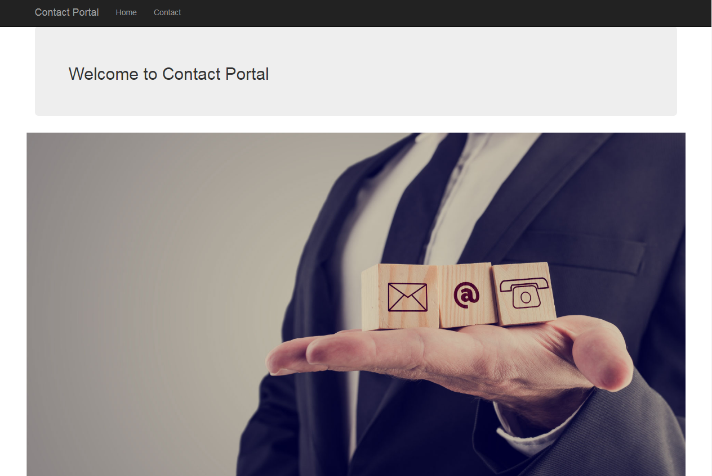

**List**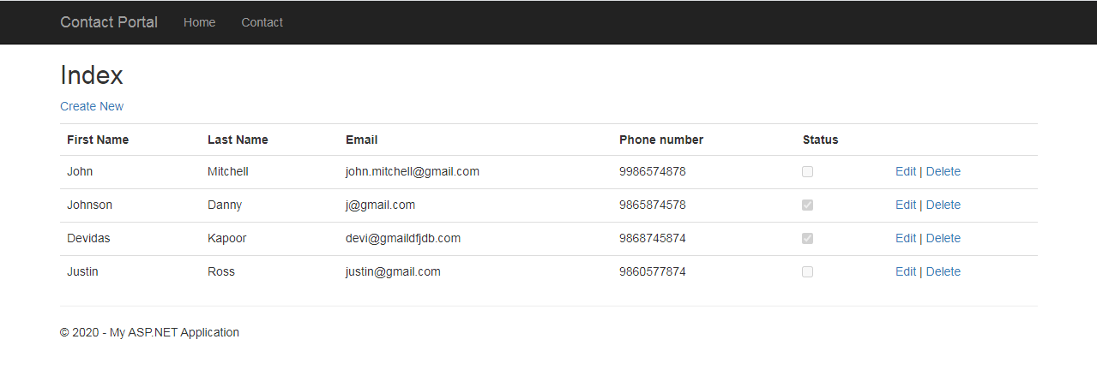

**Details**

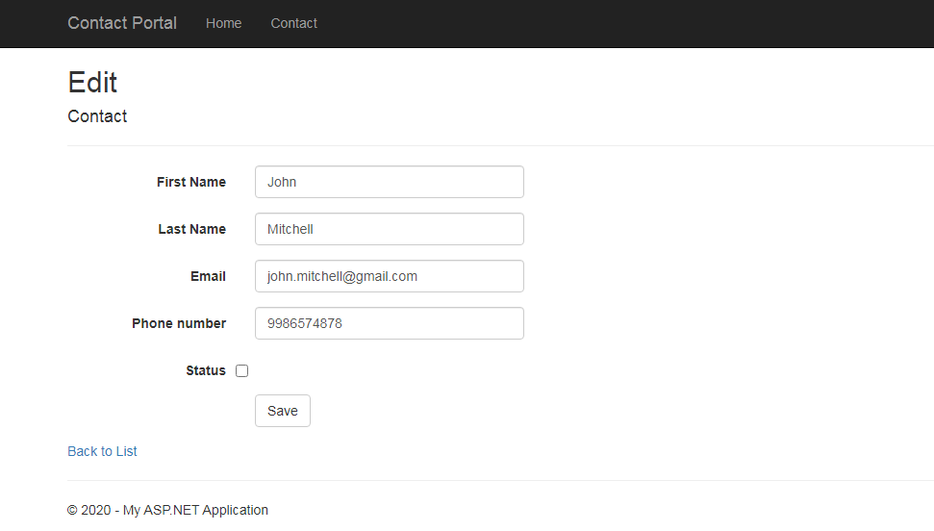

**Delete**

